Automatic Dyeing Machine

Instruction manual

November 2017 10 release implementation in November 2017 Shandong Wei Cha Microbial Technology Co. Ltd.

Record holder： Shandong Wei Cha Microbial Technology Co. Ltd.
Number of vouchers for record：The No. 20150242 Lu Ji device equipment
Number of product technical requirements：The No. CW20170901 Lu Ji edible and medicinal device equipment
Number of production record：The No. 20150048 Lu Ji edible and medicinal device equipment
Production enterprises：Shandong Wei Cha Microbial Technology Co. Ltd.
Registered address：Room 319, building 2, overseas Pioneer Park, No. 19 Huaneng Road, Lixia District, Jinan, Shandong
Contact / fax：0531-82373282
After-sales service provider: Shandong Wei Cha Microbial Technology Co. Ltd.
After service provider address：Room 319, building 2, overseas Pioneer Park, No. 19 Huaneng Road, Lixia District, Jinan, Shandong
After-sales service provider telephone：0531-82373282
Catalogue
1. Product Overvie 3
1.1 Introduction of automatic dyeing machine 3
1.2 Working principle of automatic dyeing machine 3
1.3 Indication 3
1.4 Contraindication 3
3
1.5 Model and specification 3
1.6 Working conditions and environment 4
2. primary structure 4
2.1 Introduction of equipment structure 4
3. technical parameter 5
4. Equipment operation 6
4.1 Home page 6
4.1 Control panel 7
4.2 dyeing 16
5. Installation and debugging of equipment 17
5.1 Installation conditions 17
5.2 Instrument debugging 17
6. considerations 17
7. Maintenance and maintenance of products 18
7.1 Transport and storage conditions 18
7.2 Cleaning and maintenance 18
7.3 Method of fuse replacement 18
8. Sign description 19
9. Random appendage 20
10. Warranty and service 20
10.1 Guarantee 20
10.2 Technical service information 20
10.3 Discarding and disposing 20
11. Device label 21

Product overview

1.1 Introduction of automatic dyeing machine
Automatic film dyeing machine is developed by Shandong inspection Microbial Technology Co., Ltd., which is used for dyeing cells, blood and humoral components before case analysis.

The automatic dyeing machine is widely used in dyeing process because of its simple operation, high efficiency and stable dyeing results. It has been adopted by the pathology department of the major hospitals and gradually replaced the traditional artificial dyeing. The automatic dyeing machine developed by our company is a high-tech product. This product will automate the whole dyeing process. The whole process has the control of micro controller. The human-computer interaction interface is easy to operate and easy to use. Therefore, the automatic dyeing machine designed and manufactured by our company is deeply loved by the medical workers with its unique characteristics.

1.2 Working principle of automatic dyeing machine
First, put the target slides into the slide frame, select the program that needs to run, the manipulator automatically starts to carry the dyeing process with the slide frame according to the needs of the program. After the dyeing completion, the machine will send a sound alarm and show the "operation completion, please take out the glass frame" prompt information on the display screen and operate. People take out the slide rack and press the exit program on the screen.

1.3 Indication：
It is mainly used for staining of cells, body fluids and blood components before case analysis.

1.4 Contraindication：

No

1.5 Model and specification
Product name：Automatic dyeing machine
Model specification: see the next table

Model | CW—120、CW—600、HD-600i
Rated  Voltage | AC220V 50Hz
Power | ≤300VA
Volume | 1070(length）X 580（width）X 650（height）mm³

1.6 Working conditions and working environment
- power supply voltage: AC220V；
- power frequency: 50Hz；
- ambient temperature:+10℃～+35℃；
- air relative humidity：10%～85%
- atmospheric pressure: 70kPa～106kPa

primary structure

2.1 Introduction of equipment structure

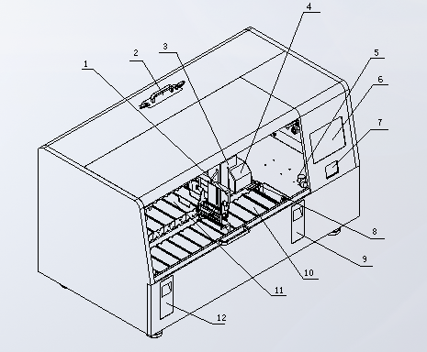
图1
Frontal view：
1. Hook 7. Card swipe
2. Filter cotton 8. Loading cylinder
3. Improve the manipulator housing 9. Loading drawer
4. Horizontal manipulator shell 10. Reagent cylinder
5. Flow control valve 11. Flow cylinder
6. Touch display 12. Uninstall drawer
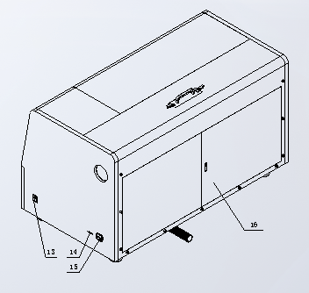
图2
Back view:
13. Power switch
14. USB (optional)
15. Power outlet
16. Maintenance window

technical parameters
- The sample slide yield………………………………At least 200 tablets per hour; up to 600 tablets
- The sample slide yield……………………………………………………… At least 200 tablets per hour; up to 600 tablets
- The loading capacity……………………………………………… Up to 30 pieces
- The amount of input…………………………30 pieces / frames (continuous input)
- The total number of sites ………………………………………………… Up to 26
- The total number of the reagent site………………………………………………………… At least 23
- The reagent container capacity…………………………………………………………… 450ml
- The total number of sites flushing………………………………………………………… Up to 5
- Oven…………………………………………………………………… At least 1
- The oven temperature……………………………………………… 30℃ to 70℃
- The heating agent site…………………………………………………… Up to 4
- The site temperature heating reagent………………………………………………… 30℃ to 70℃
- The incubation time set…………………………………………………One second to 99 minutes and 59 seconds
- The fixed memory capacity………………………………200 programs have a maximum of 50 steps per program
- The working temperature range…………………………………………………………15℃ to 35℃
- The relative humidity…………………………… Maximum 80%, no condensation
- The rated voltage………………………………………………………220V±10%
- Rated frequency……………………………………………………………… 50Hz
- The size (length X width X height)…………………………1200X700X650(mm)
- Weight………………………………………………………………………… 70kg

device operation

4.1 Home page

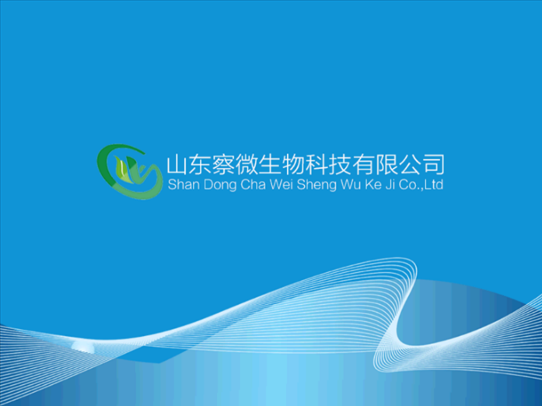
Figure 3 opening interface

After opening the instrument, the device enters the standby state. After pressing the entry button, the device enters the main interface.

4.1 Control panel
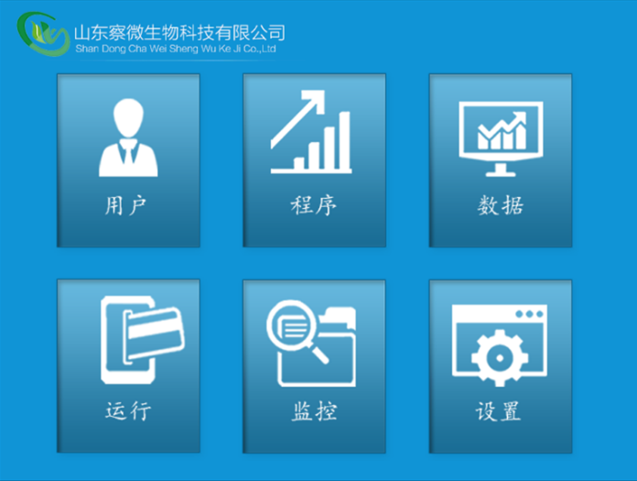
Figure 4 main menu

4.1.1 program：
Click the program icon to enter the program setup interface, and provide the editing, copying, deleting and modifying functions of the program.
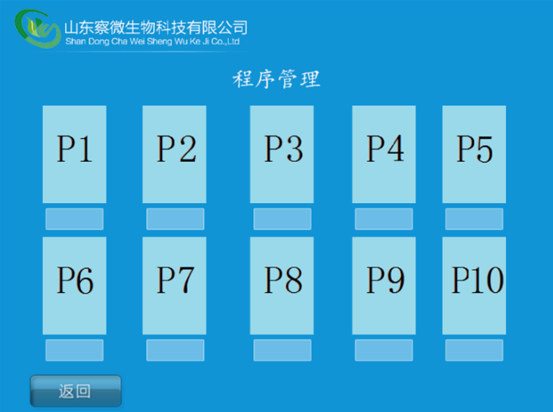
Figure 5 program home page

- The name of the P1-P10 program is empty for the first time, and it can also be emptied by the operator.
- When the PX is selected, the corresponding input interface is shown by clicking the corresponding step with the hand, as shown in Figure 6. The input function of the parameters can be completed by input or selection of the corresponding letter or number according to the need.
- After entering all parameters of the program, press the confirmation button, and the program is automatically saved.

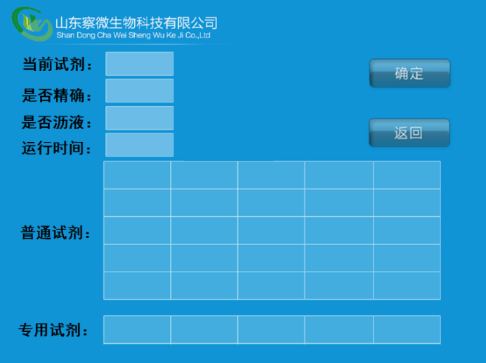
Figure 6 program adding steps

4.1.2 Set up：
Click the set icon to enter the designated interface of cylinder block reagent, and provide the function of reagent placement in the reagent cylinder of the dyeing machine.
The specified operation is as follows:
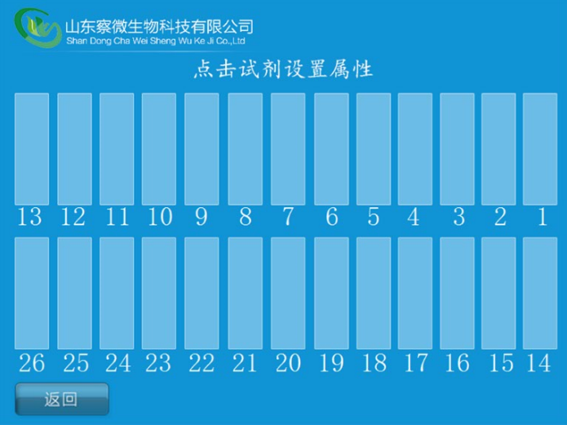
Figure 7 cylinder property setting interface
- Click on the corresponding cylinder number to select the type of reagent to set.
- After setting up all cylinder reagents, press the exit button and automatically assign the designated reagent types.

4.1.3 user：
Click the user icon, enter the user management interface, can add users, delete users, modify the password, user login operation, the specific operation method is as follows:
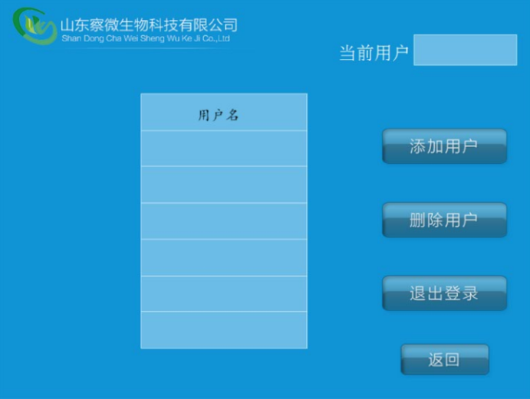
Figure 8 user management interface

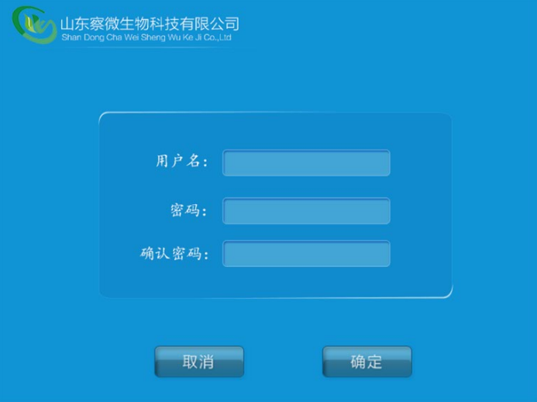
Figure 9 add the user interface
Add users:

- Click add user button to pop-up and add user interface. Note: only ADMIN user has this permission.
- Touch the input bar, pop up the soft keyboard, input the name, password and confirm the password in turn, the password is composed of 6 letters and numbers.
- Click OK button to complete user add; click Cancel button, and abandon user add.

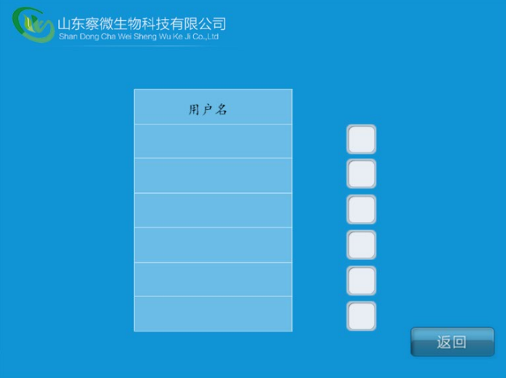
Figure 10 deleting the user interface
Delete users:

- Click the check box behind the name of the existing user in Figure 10.
- The system automatically removes selected user information

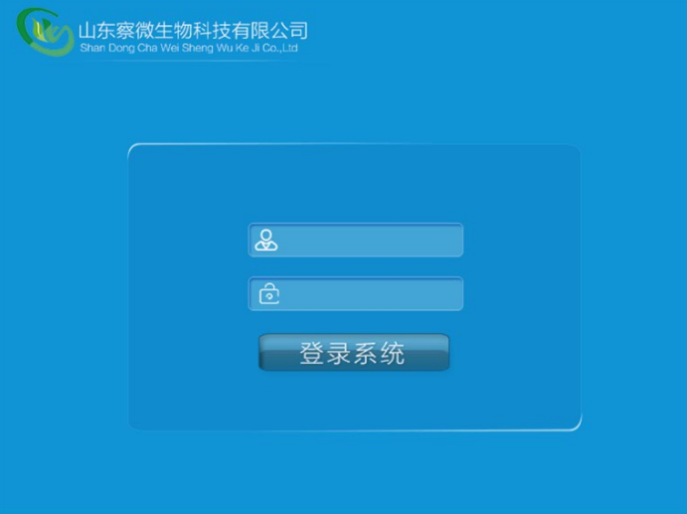
Figure 11 user login interface
User login：

- First, the system starts to reset, and completes the automatic pop-up 11 operation interface.
- Input username and password.
③ Click the login button, you can have permission to operate the machine.

4.1.4 Monitor：
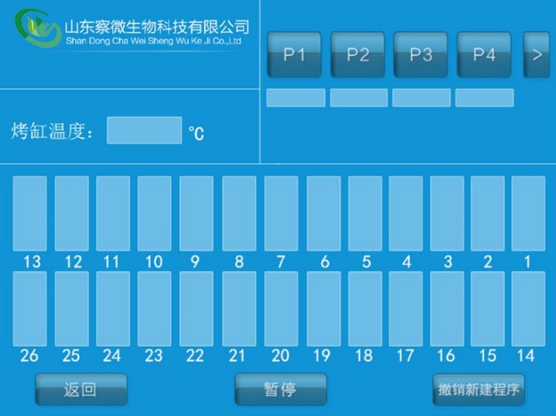
Figure 12 monitoring interface

- Click on the monitor button in Figure 4, and display the interface shown above.
② This interface displays all the program information that is currently being executed, including the current execution to the cylinder, the current time and date, the temperature of the tank, the temperature of the roast cylinder, the name of the current execution program, the remaining time of the program, and so on.

4.1.5 Function：
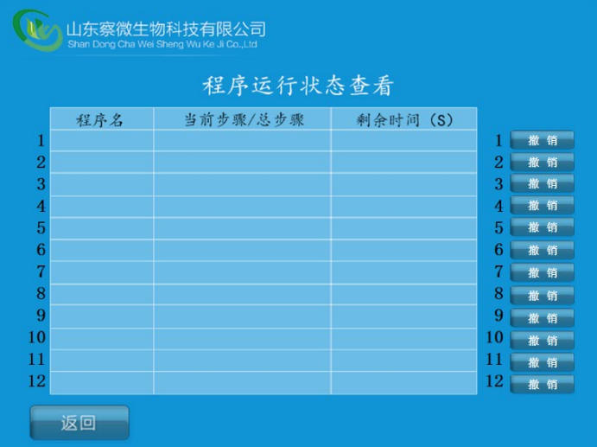
Figure 13 running state

- Click the ‘run’ icon in Figure 4 to display the interface shown above.
② This interface displays the detailed information of the currently running program. Clicking the corresponding revocation button can cancel the program that does not want to run at any time.

4.1.5 data：
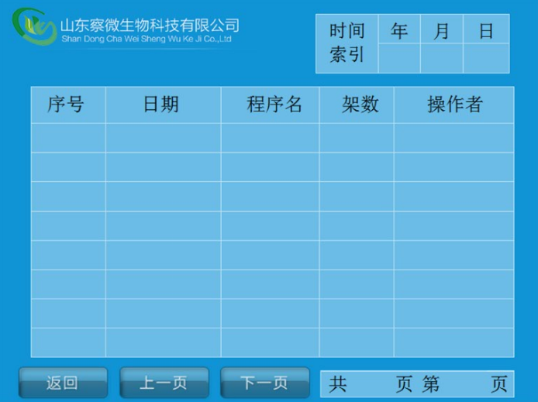
Figure 14 historical data information

- Click on the ‘data’ icon in Figure 4, you can choose query history, as shown in Figure 14.
- This interface is used to view historical data.
- up to 12 frames can be continuously input, that is, 30 pieces of *12 rack =360.

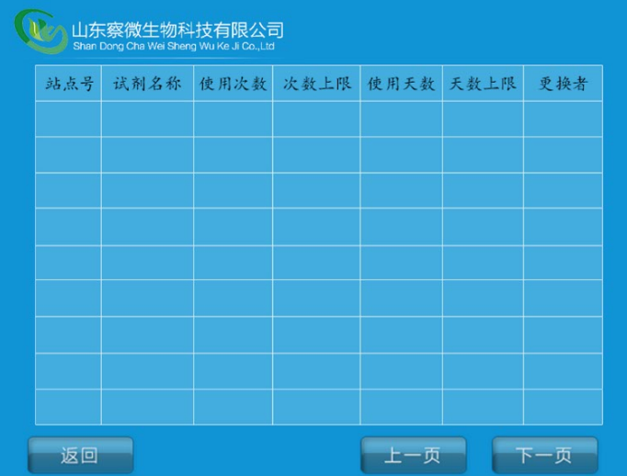
Figure 15 reagents information view

- Click on the "data" icon in Figure 4, you can choose query reagent information, as shown in Figure 15.
- This interface is used to check the usage times and the remaining number of the current reagent in each reagent cylinder.

4.2 dyeing
Before starting the dyeing program, we must prepare according to the following steps：
- Connect all the inlet and drain pipes, and ensure good sealing.
- Connect the power cord, turn on the power switch on the device, and the device will enter the standby state.
- The site must be reconfigured and injected according to this configuration.
- If the coloring program that needs to be used is not stored in the device, please edit the Dyer that needs to be used. If you have already edited, please select the program that you need to run.
- Open the protective cover, put the needed slide holder into the loading drawer, and load the slot to zero.
- Select the coloring program to execute, start the dyeing
- Wait for the machine to sound and alarm, finish dyeing, remove the slide holder from the unloading drawer, and uninstall the drawer to zero.
- Cover the protective cover and turn off the power switch of the equipment.

Installation and debugging of equipment

5.1 Installation conditions
- Automatic film machine requires the use of 1.5m long, 1m wide fixed platform with good ventilation conditions.
- The power supply voltage is AC220V 50Hz, and the connection part between the device and the network must have more than 2 times capacity.
- The rating current of the fuse is 3A.
- Check whether all functions of the equipment are normal after electrifying.
- Professional training for medical staff who use instruments to avoid operational errors.
- The automatic staining machine should be placed in at least 20m2 rooms. The electrical installation space involves grounding system, grounding fault interruption system and so on.
- The corresponding inlet / drain on the instrument is 2.5m away from the faucet and the longest distance from the drain pipe to 2m.
- There should be enough space above the experimental table (about 0.9m) to facilitate the opening and closing of the instrument door components.

5.2 Instrument debugging
- Insert the power cord into the three wire single-phase standard socket, connect the power supply, and turn on the power switch.
- Observe and operate the function buttons on the LCD screen to check whether the function is specified.
- Test the feasibility of loading drawer and unloading drawer on the machine.
- Choose the machine's own test dyeing program, check whether the three axis manipulator, baking cylinder and water cylinder have the expected function.
- Turn off the power debugging end.

Matters needing attention
- Is this machine when replacing the fuse must unplug the power plug and choose the same types of insurance.
- This machine is only by trained professional doctors and in strict accordance with the provisions of the operation.
- Please read the instructions carefully before use. If you do not damage the machine or cause other consequences, the company does not take any responsibility.
- Good grounding of the machine is a guarantee of safe use. It must be connected with the earth (with a single-phase three stage socket with good protection and grounding) to avoid accidents.
- To use, do not open the cabinet, and no liquid into the machine, in order to avoid the accident.
- The use of tools to open the cabinet before, have to pull out the power line plug.
- The use of such as equipment failure should be immediately cut off the power supply.
- The user if the instructions, to the manufacturers should be away for.
- Is in the sample, such as the discovery of the sample adding slot near the temperature is too high, please disconnect the power supply equipment.
- The kit used in the test tube into the designated medical garbage box.
- It can not be used at the same time with the high-frequency surgical equipment. The equipment near the short wave and microwave treatment equipment may cause the work of this equipment not normal.

Maintenance and maintenance of products

7.1 Transport and storage conditions
- The automatic film dyeing machine after packing is allowed to transport by general means of transportation, but it should prevent violent sports, impact and rain and snow splashing.
- The automatic film dyeing machine should be stored in indoor environment with ambient temperature of 0 ~ 50 C, relative humidity less than 85%, no corrosive gas and well ventilated room.

7.2 Cleaning and maintenance
- Inside the instrument, remove the reagent cylinder and flushing container, clean the stainless steel inner wall with ordinary neutral detergent, and then clean the stainless steel inner wall. Rinse with water.
- The mechanical arm, of the robot arm contains electronic components, so it can not be cleaned with liquid and liquid, and it can only be gently wiped with a little damp cloth.
- Clean the outer surface of the instrument with mild detergent on the outside surface, then wipe it with a wet cloth.
- Touch screen Use a commercial screen cleanser to clean the touch screen.
- Reagent cylinder Use the standard laboratory dishwasher cleaner to clean the reagent cylinder.
- Sewerage / pipe Check whether the waste water pipes accumulate dirt, especially algae. To prevent the growth of bacteria, we must wash the drainage system with 5% sodium chlorate and rinse with plenty of water.
7) Slide frame Clean household or laboratory cleaners according to need.
8) Oven Regularly check the paraffin collection tray at the bottom of the oven for paraffin residues, and clean it.

7.3 Method of fuse replacement
- Remove the power plug, use a word screwdriver to remove the cover from the power outlet, take out the bad insurance, replace the same type of fuse, and cover the cover.
- The fuse type: F3L250V.

Sign description
1 |  | B type equipment
2 |  | Protective grounding
3 | 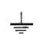 | Ground
4 |  | Pay attention to random documents
5 |  | Fragile
6 | 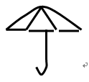 | Moisture-proof
7 |  | Upward
8 | 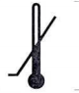 | Lower temperature limit
9 | 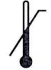 | Upper limit of temperature
10 |  | Fuse
11 | 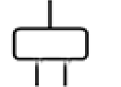 | The power plug
12 | 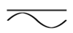 | AC and DC
13 |  | AC

Random appendage
- Use the instructions
- Power cable
- Reagents
- Product qualification certificate
- Fuse F3L250V
- Reagents cylinder
- Heating reagents cylinder
- Water washing reagent cylinder
- Inlet pipe
- Outlet pipe

Warranty and service

10.1 Guarantee：
The company's guarantee of the delivery of the contract products is based on the overall quality control procedure based on our internal testing standards, and the product is in good condition and meets all technical specifications and / or the specified guarantee features.
The scope of the warranty is based on the content of the agreement. It is a free warranty period within one year from the day of sale (for example, human damage is not within the scope of warranty) and is maintained for a lifetime.

10.2 Technical service information ：
If you need technical service or replace parts, please contact our company. Please provide the following information:
- The instrument type and name.
- The instrument location and contact name.
- Reasons for service requests
- The date of delivery.

10.3 Discarding and disposing：
Components of instruments or instruments must be processed according to local regulations.

11 Device label

Product name ： Automatic dyeing machine
Product model ：CW—600
Product number ：xxxxxxxx Date of manufacture :
Input power ：≤300VA Input voltage :AC220V 50Hz
Number of technical requirements ： The No. 20150242 Lu Ji device equipment
Number of vouchers for record ： The No. 20150242 Lu Ji device equipment
Number of production record ： The No. 20150048 Lu Ji edible and medicinal device equipment
Contact number ：0531-82373282
Manufacturer ： Shandong Wei Cha Microbial Technology Co. Ltd.
Production address ： Room 319, building 2, overseas Pioneer Park, No. 19 Huaneng Road, Lixia District, Jinan, Shandong
No other related contents are noted, see the instructions for use.

Product name ： Automatic dyeing machine
Product model ：HD—600i
Product number ：xxxxxxxx Date of manufacture :
Input power ：≤300VA Input voltage :AC220V 50Hz
Number of technical requirements ： The No. 20150242 Lu Ji device equipment
Number of vouchers for record ： The No. 20150242 Lu Ji device equipment
Number of production record ： The No. 20150048 Lu Ji edible and medicinal device equipment
Contact number ：0531-82373282
Manufacturer ： Shandong Wei Cha Microbial Technology Co. Ltd.
Production address ： Room 319, building 2, overseas Pioneer Park, No. 19 Huaneng Road, Lixia District, Jinan, Shandong
No other related contents are noted, see the instructions for use.

